CENTRAL UNIVERSITY OF RAJASTHAN
Department of Culture and Media Studies
July 2018 – May 2019

CMS Students’ in 5th Talk Journalism (10th – 12th August, 2018)
The students of 2017 & 2018 batch actively participated in a media event – Talk Journalism in Jaipur and successfully completed a two days workshop on “How to make and sell a documentary” by International Documentary Filmmaker Siok Siok Tan (Singapore).
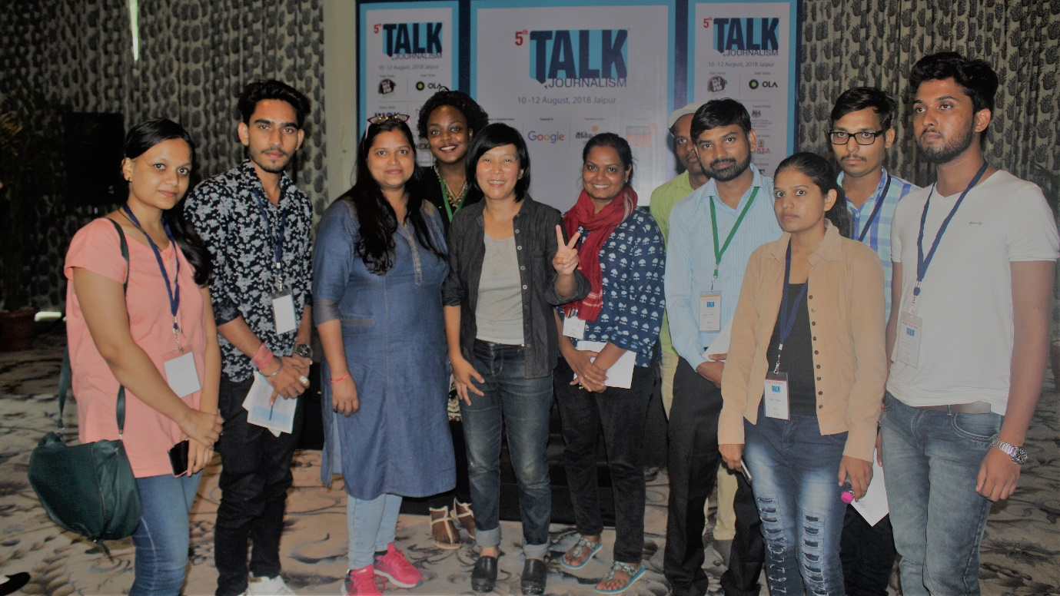
Department Induction Programme for Freshers (13th August, 2018)
Academic session 2018-19 began with Induction Programme for the Freshers (M.A. & Ph.D) where they were introduced to the courses, activities, and exam pattern in the Department. The final year students received their certificate of participation in the event ‘Talk Journalism’ from Prof S.N.Ambedkar, Head of Department and Dean, School of Social Sciences.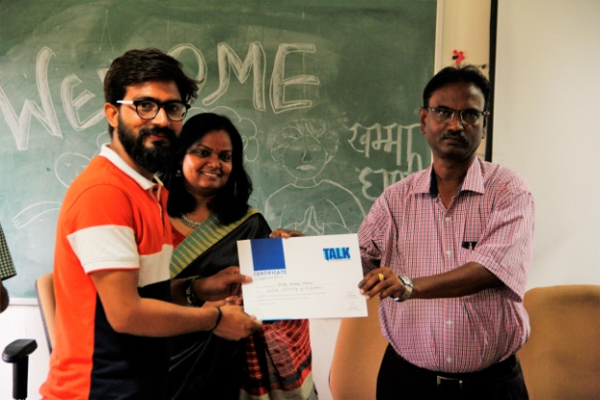 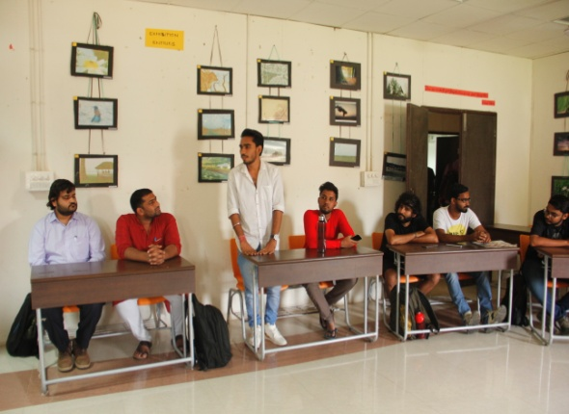

Two days workshop on Aesthetics of Cinema (4th – 5th September, 2018)
Mr. RajKishor Arya and Mr.Deepak Kumar, Independent Film Makers, Winners of the prestigious Golden Beaver Award conducted a two days workshop on Aesthetics of Cinema where students learnt the art of short film making through mobile.
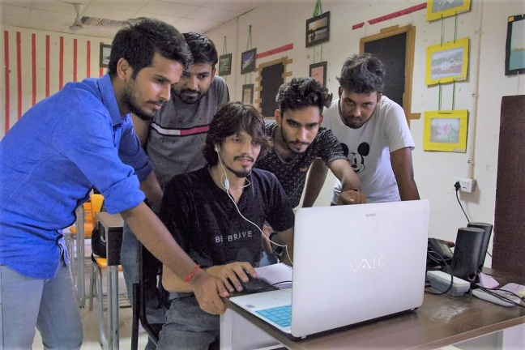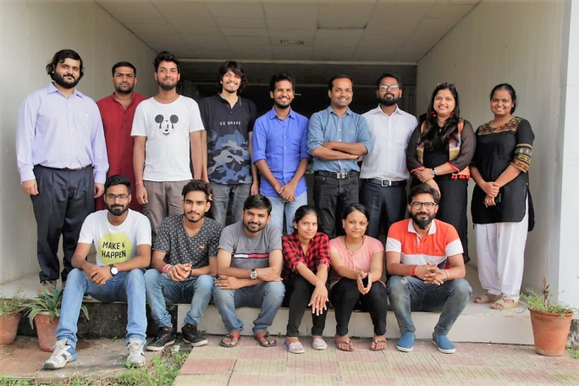
4th Media Fest – Media Utsav (29th – 31st October, 2018)
The Department celebrated its 4th Annual Media Fest – Media Utsav 2018 where entries were invited for photography competition, caption writing, photo feature, ad-mad open to all. Participants throughout the country and world sent their photo entries in department facebook page – www.facebook.com/CMSDeptCURAJ. The event ended with cultural programme and prize distribution.
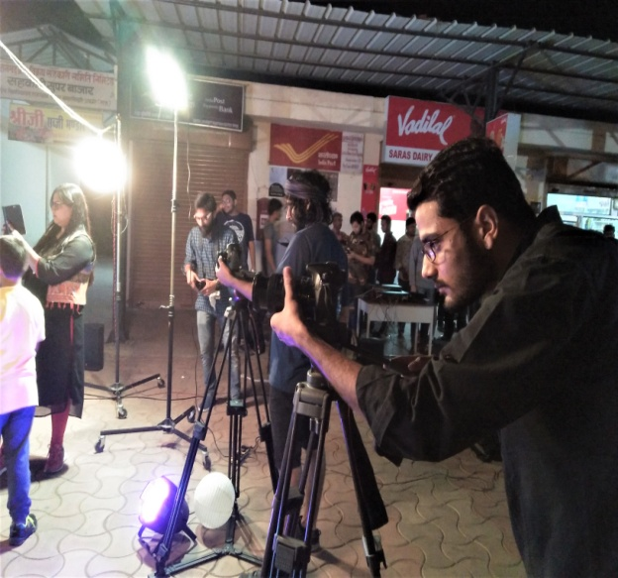
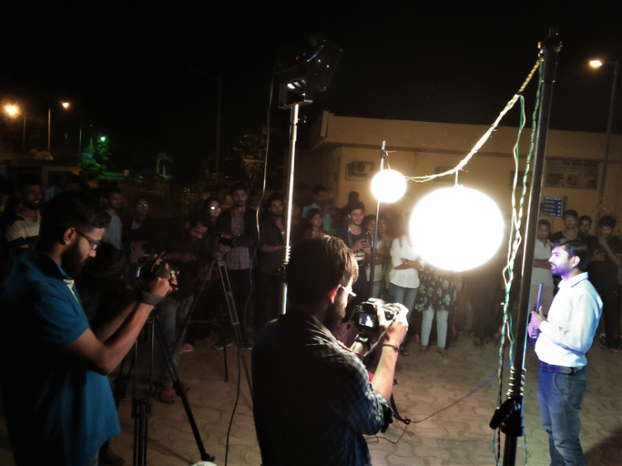

Lecture on Educational Audio-Visual Programme (9th January, 2019)
Dr. Amit Kumar, Assistant Professor, School of Journalism and New Media Studies, IGNOU (New Delhi) introduced the students about making educational videos and how they can contribute towards the digital learning process.
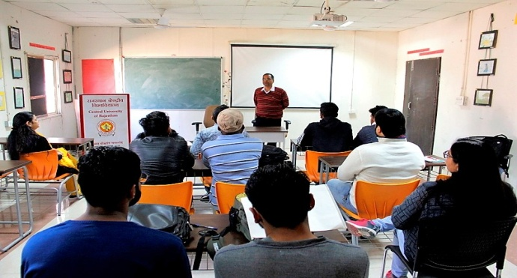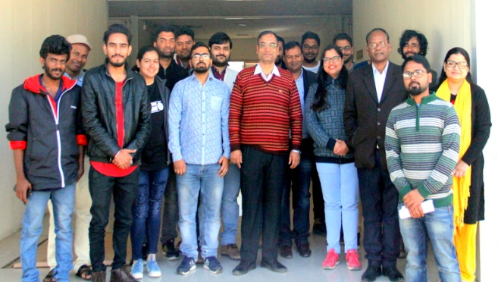
Google Talk Initiative on Fake News (18th January, 2019)
The Department in collaboration with Google Inc. conducted a talk-cum-workshop on ‘Fake News’ where Mr. Ashutosh Jha, Sr. Journalist (ETV Bharat) explained the perils of fake news and explained the mechanisms to identify the fake news, images, and videos that would help prevent the spread of fake news.
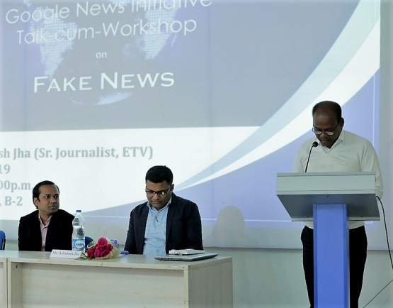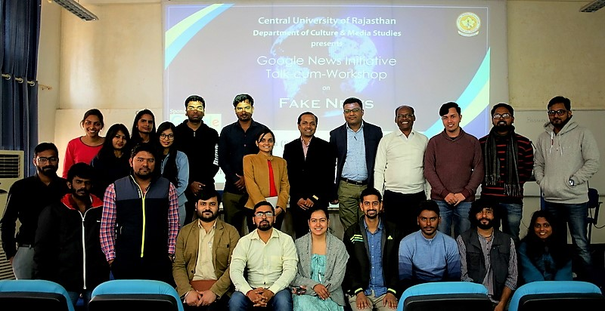
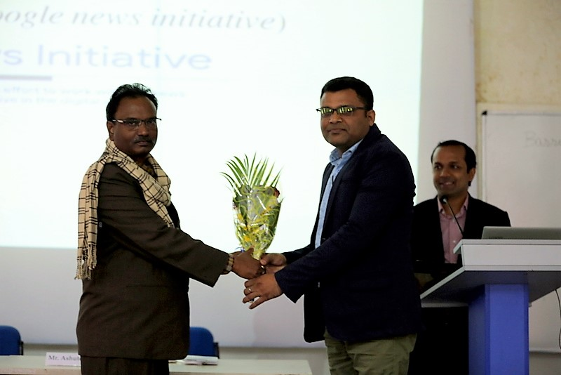
Workshop on Mobile Journalism (26th March, 2019)
Mr. Uma Shankar Singh, Editor Foreign Affairs, NDTV (New Delhi) carried out a day long workshop on reporting, capturing video, and telling stories from the field through mobile phone, encouraging a perspective towards citizen journalism.
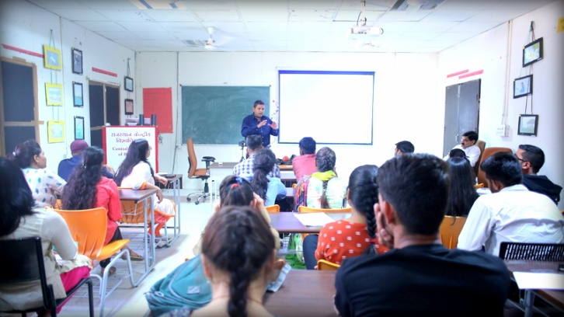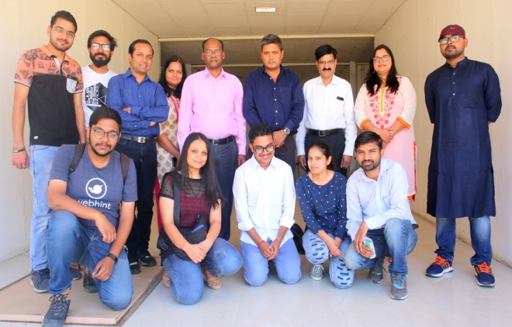

5 days Workshop on Video Editing (1st – 5th April, 2019)
Mr. Shiv Narayan Pandey, Senior Editor, News 24 Channel (Delhi) conducted a five days workshop on the process of video editing, usage of editing software, and evaluated the video projects done by the students.
