CENTRAL UNIVERSITY OF RAJASTHAN
Department of Culture and Media Studies

World Photo Day (19th August)
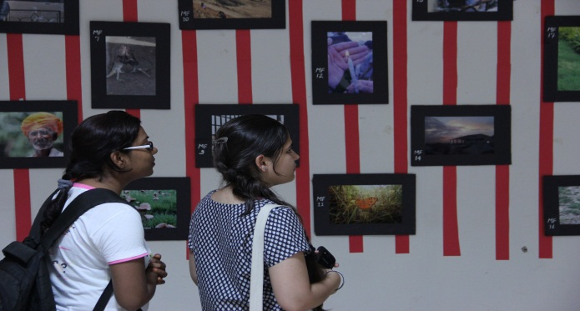
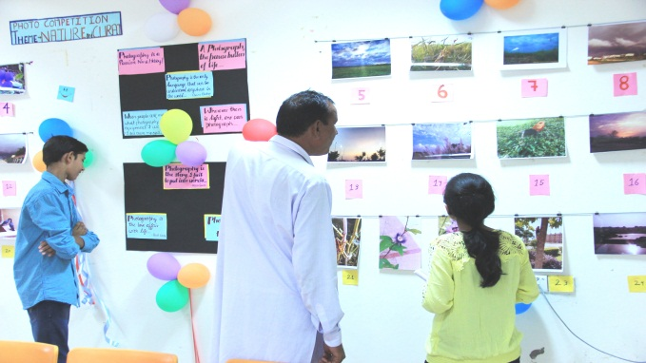
The Department celebrated World Photo Day on 19th August,2016 by organizing Photography Competition, Photo Exhibition, Photo Story Competition and Caption-Writing Contest open to students, faculty members and non-teaching staff of the University. Dr. Junali Deka (Asst.Professor,CMS Dept) co-ordinated the event.
Dance as a Therapy Workshop (July, 2016)
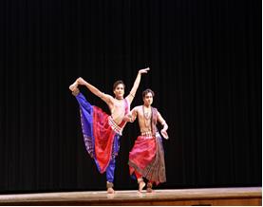
The Dance club of the Department organized a five days (26 -30th July) dance as a therapy workshop for the students by renowned Odissi Dancer Mr. Saswat Ranjan Joshi and Mr. Bibhudatta Das. The students of the Dance Club participated in the workshop with great enthusiasm and benefitted from it. Dr. Pranta Pratik Patnaik, (Asst.Professor,CMS Dept) was the co-ordinator of the workshop.
Documentary Proposal Writing Workshop (September, 2016)
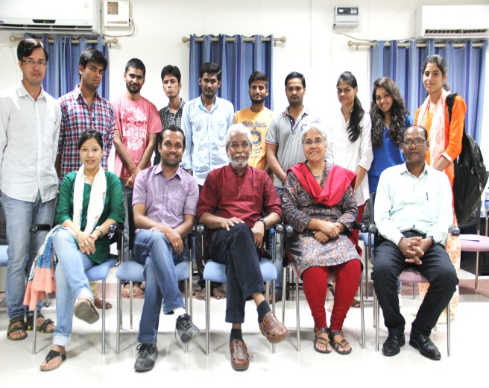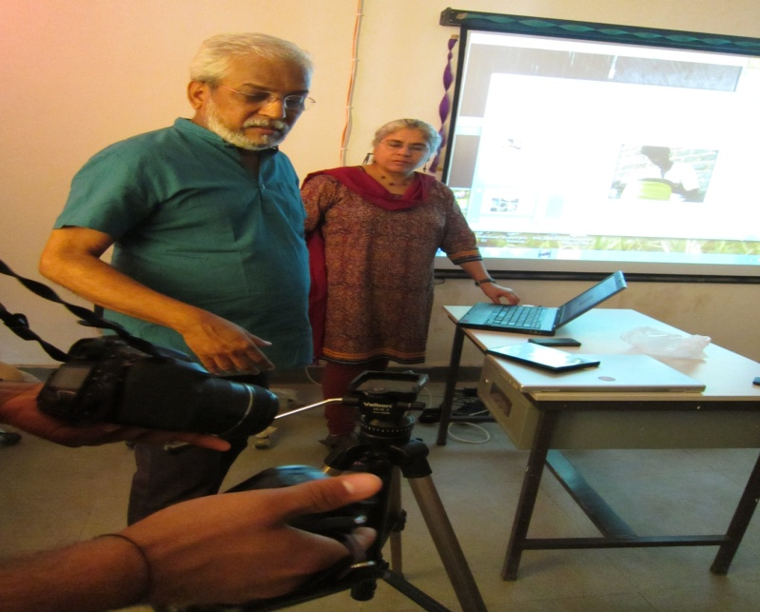
Prof. Anjali Monteiro and Prof. K.P.Jayasankar from Tata Institute of Social Sciences (TISS) Mumbai did a five day workshop on the basics of proposal writing for documentary making from 13th – 17th September, 2016 for the 3rd Semester students.
Video Production Workshop (September, 2016)
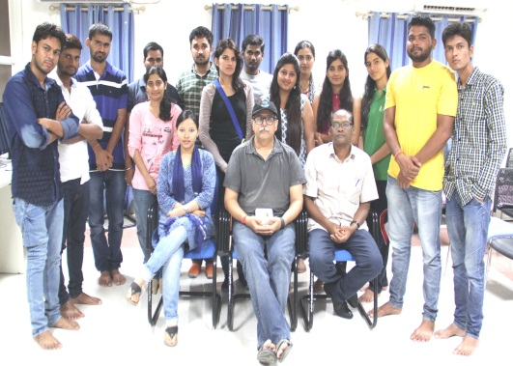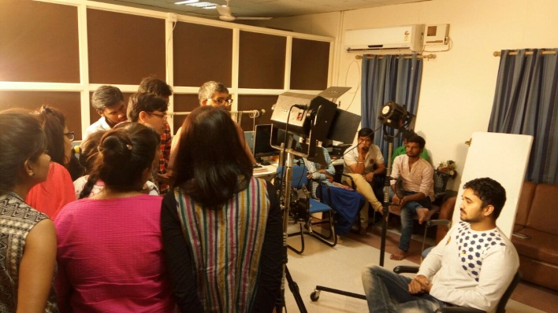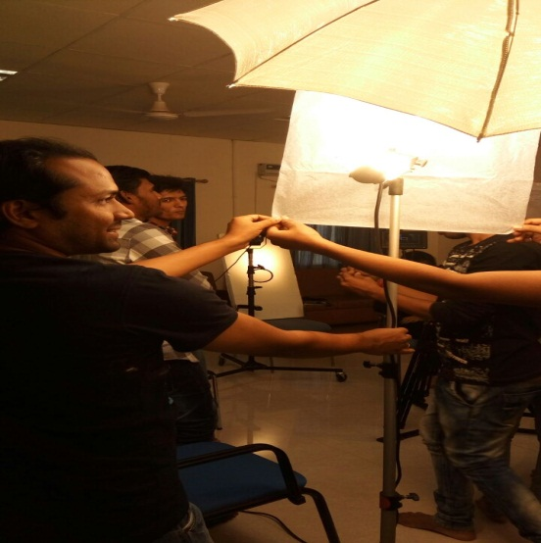
Mr. Hiroo Keswani, Cinematographer from Mumbai film Industry did a 3 day video production workshop from 9th – 11th September conducting practical training for 1st & 3rd semester students on lighting and shooting through video camera.
Two Day National Seminar on ‘Media & Subalterns in India’ (March, 2017)
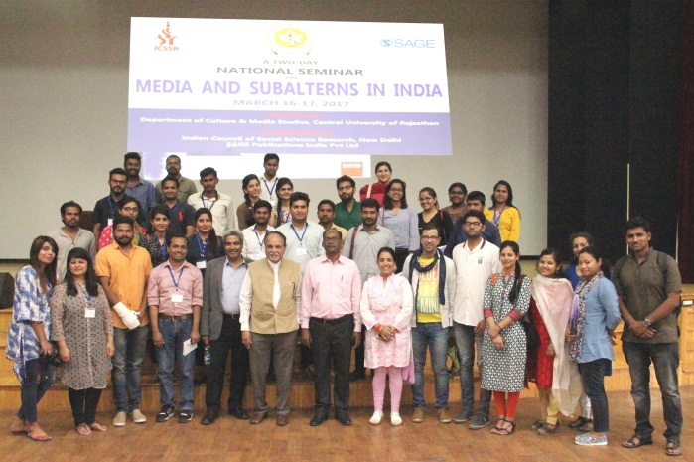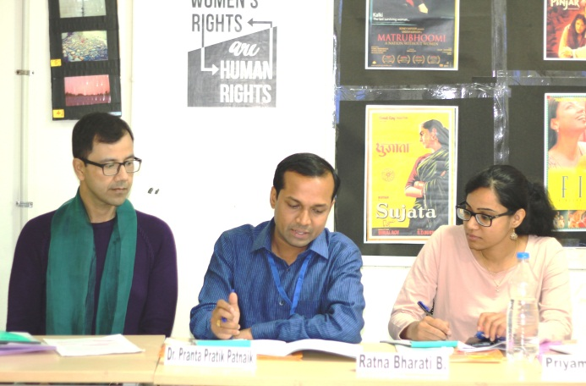
A two day national seminar on “Media and Subalterns in India” was held by the Department of Culture and Media Studies on 16th – 17th March, 2017. Prof. Sisir Basu (BHU, Varanasi) and Prof. Biswajit Das (Jamia Millia Islamia, New Delhi) were the key note speakers in the inaugural and valedictory session respectively. It attracted faculty members, research scholars and media practitioners all around the country. It covered issues of Dalits, tribals, sexual and ethnic minorities in relation to media representations. Dr. Nicholas Lakra (Asst.Professor, CMS Dept) was the convenor of the seminar. The seminar was supported by ICSSR, New Delhi and Sage Publications.
Sound Recording Workshop (March, 2017)
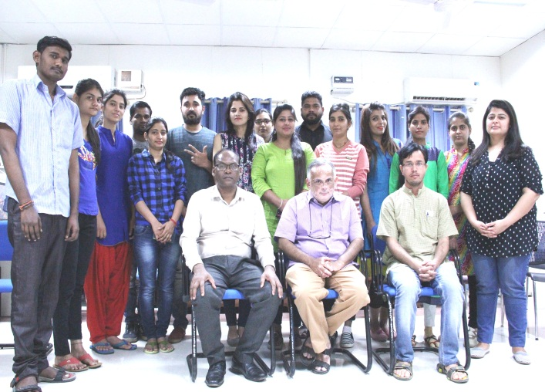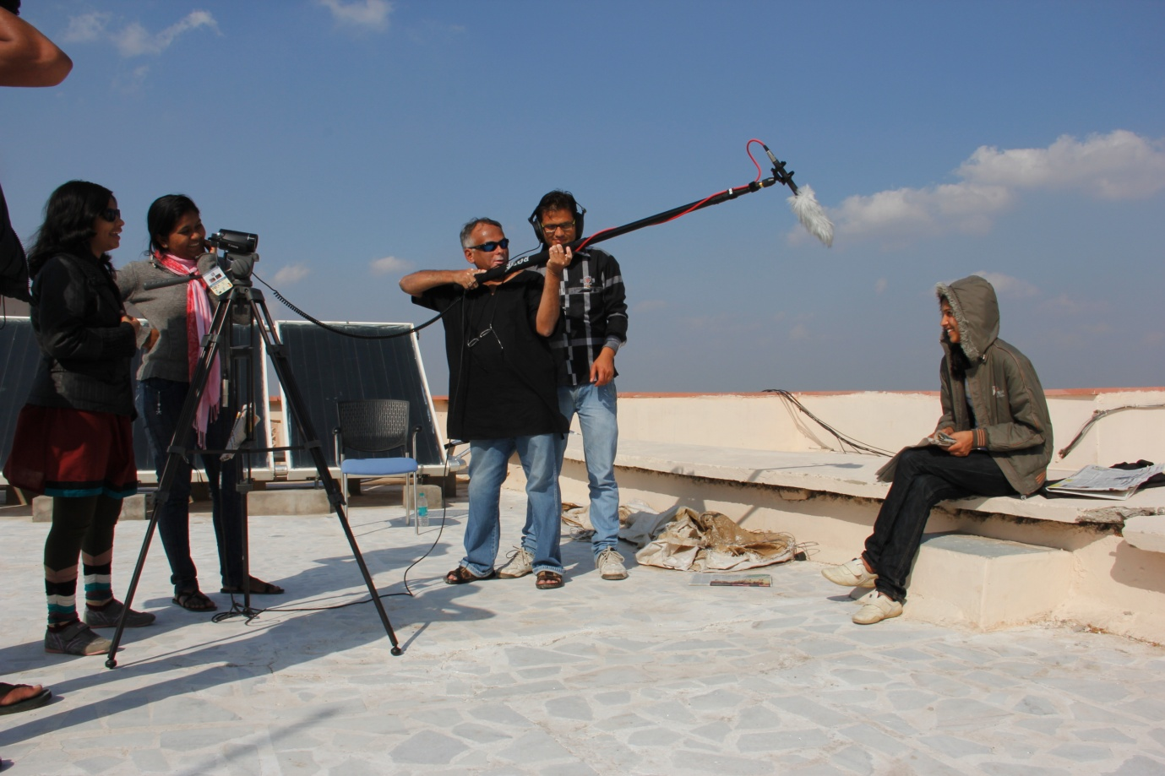
Mr. Suresh Rajamani, alumni of Film and Television Institute of India (FTII, Pune) and award winning sound recordist gave a hands on training to the students on sound recording for video and documentary film production during 20th – 24th March, 2017.
Five Days Workshop on Basics of Video Production (August, 2017)
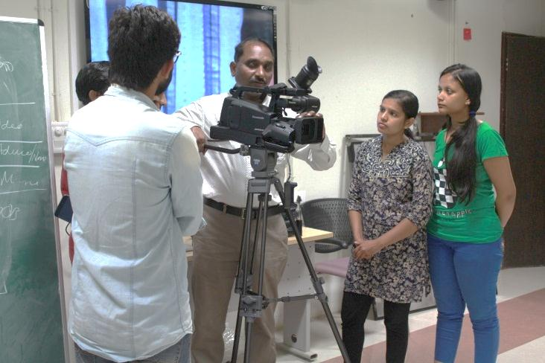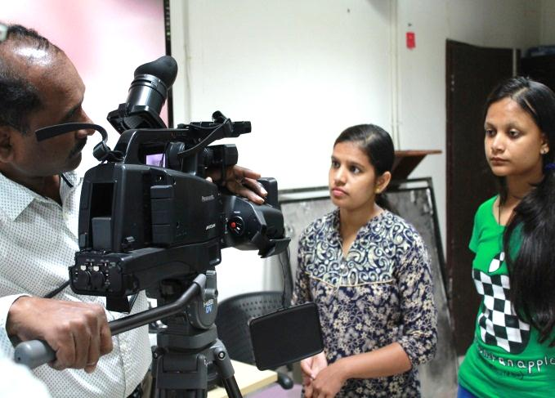
Dr. Pilli Kennedy from Department of Communication, University of Hyderabad delivered lectures and conducted practicals for first year students about the basics of video production during 28th August – 1st September, 2017.
Documentary Film Making Workshop (September, 2017)
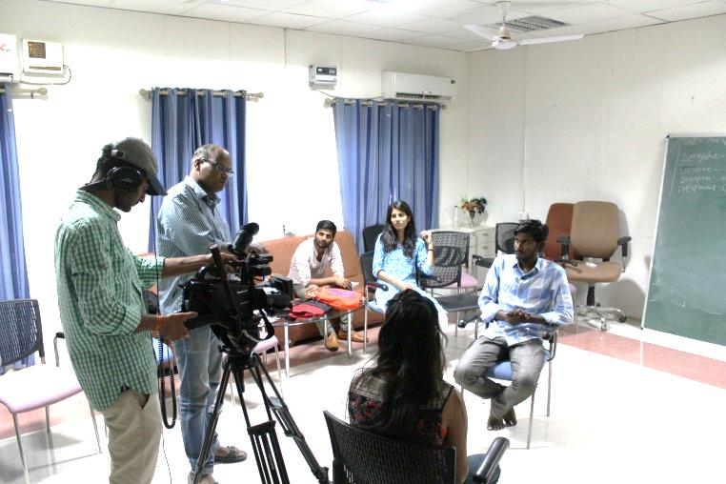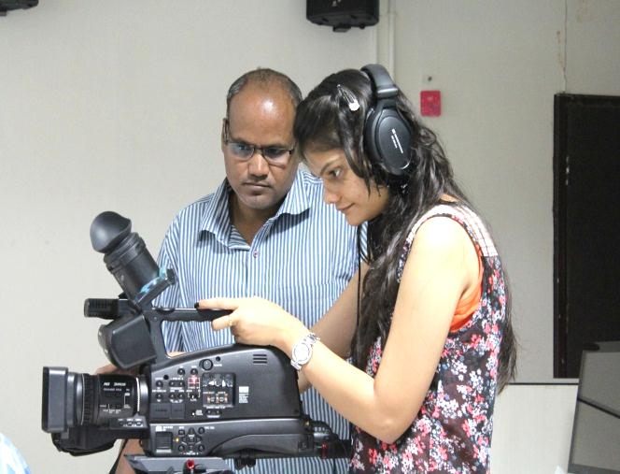
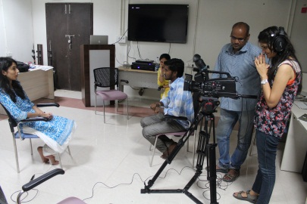
Shri Mohan Kumawat and Smt. Sania Hasmi, award winning documentary film makers from Anhad Media Production House, Delhi conducted a five days workshop on Documentary Film Making w.e.f. 25th September – 29th September, 2017 for the 3rd Semester students.
3rd Media Fest of CMS Dept - Media Utsav, 2017 (October, 2017)
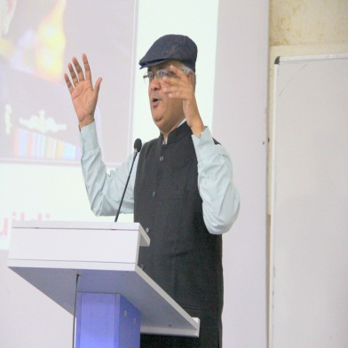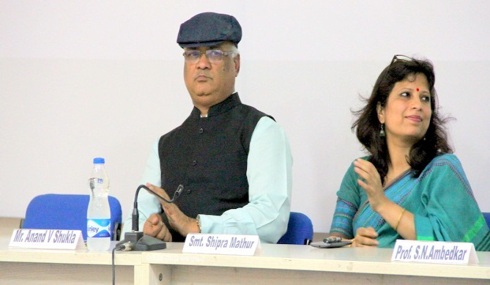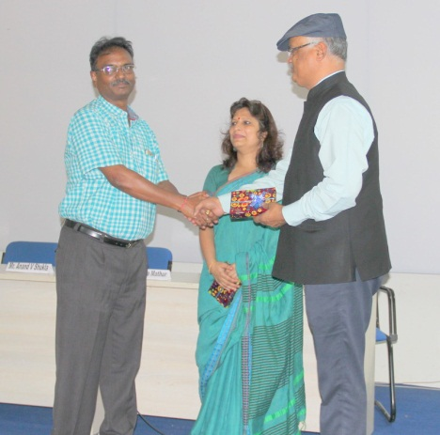
Department of Culture and Media Studies organized its 3rd Media Fest – Media Utsav,2017 on 4th October. Smt. Shipra Mathur, Chief Editor of Rajasthan Patrika & Founder of PenMedia Foundation, Jaipur delivered her talk on ‘Media Strategies for Social Change’. Mr.Anand Verdhan Shukla, Ex-IGP, Rajasthan Cadre motivated the students through his talk on ‘Role of culture in Nation-building’. Both the inspiring talks were followed by screening of documentaries made by the students of the department. (Link of the documentaries - https://www.youtube.com/channel/UCKe10ibn_m2JGjKekTRUe3g/videos.

